**Front End Engineering-II**

Project Report

Semester-IV (Batch-2022)

PROJECT TITLE:

BMI CALCULATOR



**Supervised By: Submitted By:**

Raveesh Samkaria Tamanna (2210990885) G-13

**Department of Computer Science and Engineering**

**Chitkara University Institute of Engineering & Technology,**

**Chitkara University, Punjab**

**Abstract:**

The BMI Calculator project aims to provide a simple and efficient tool for calculating Body Mass Index, a measure of body fat based on height and weight. In an era increasingly concerned with health and fitness, individuals seek accessible means to monitor their physical well-being. This project focuses on delivering a user-friendly web-based calculator that computes BMI quickly and accurately.

The calculator emphasizes intuitive input fields and clear output to enhance user experience. Currently, this project contains the properties of HTML, CSS, BOOTSTRAP and JAVASCRIPT. The key features include:

**Input Fields:**

Users can input their height and weight measurements in metric or imperial units, ensuring flexibility and convenience.

**BMI Calculation:**

The calculator instantly computes the BMI based on the provided measurements, offering immediate feedback on the user's body fat percentage.

**Interpretation:**

The output provides interpretation of the calculated BMI, indicating whether the user is underweight, normal weight, overweight, or obese, according to standard classifications.

**Color-Coded Feedback:**

Visual cues such as color-coded indicators accompany the BMI interpretation, enhancing clarity and aiding users in understanding their results.

**Responsive Design:**

The calculator is designed to be responsive across various devices, ensuring accessibility for users browsing from desktops, tablets, and smartphones.

In conclusion, the BMI Calculator project offers a convenient solution for individuals to assess their body fat percentage and monitor their health status. With its user-centric design, the calculator empowers users to make informed decisions about their fitness goals while promoting awareness of healthy living practices in today's health-conscious society.

**CONTENTS:**

|  |  |  |  |
| --- | --- | --- | --- |
| S. no. | Sections | Page no. | Remarks |
| 1 | Introduction | 4-5 |  |
| 2 | Problem definitions and requirements | 6 |  |
| 3 | Proposed design/Methodology | 7-9 |  |
| 4 | Results | 10-35 |  |
| 5 | References | 36 |  |
|  |  |  |  |
|  |  |  |  |

**1. Introduction:**

In the realm of health and wellness, the BMI Calculator project serves as a pivotal tool for individuals seeking to monitor and optimize their physical well-being. By providing a user-friendly interface and accurate calculations, this project aims to cater to the needs of those navigating the complexities of body composition analysis. In an era where health consciousness is on the rise and individuals increasingly rely on digital platforms for fitness tracking, the BMI Calculator offers a convenient solution for assessing Body Mass Index, a key metric in determining overall health status. Through its intuitive design and functionality, this calculator endeavors to empower users to make informed decisions about their fitness goals and adopt healthier lifestyle choices.

**1.2. Background:**

As society's focus on health and fitness continues to grow, individuals are increasingly turning to digital tools for assistance in monitoring their physical well-being. Body Mass Index (BMI) serves as a widely recognized indicator of body fatness and overall health status. Recognizing the importance of accessible and accurate BMI calculations, the BMI Calculator project emerges as a solution to meet this need. Leveraging the simplicity of HTML,CSS and BOOTSTRAP, this project offers users a user-friendly interface to input their height and weight measurements and obtain instant BMI results. By incorporating responsive design principles, the calculator ensures accessibility across various devices, catering to the diverse needs of users in today's digitally-driven society.

**1.3. Objectives:**

Through the BMI Calculator project, our primary objectives revolve around empowering individuals to take control of their health and fitness journey by providing a simple yet effective tool for BMI calculation. By offering a user-friendly interface and accurate calculations, we aim to facilitate informed decision-making and encourage the adoption of healthier lifestyle choices. Our focus on intuitive design, responsive functionality, and accessibility underscores our commitment to delivering a seamless user experience for individuals seeking to monitor their physical well-being. With the integration of color-coded feedback and interpretation of BMI results, our goal is to enhance user understanding and promote awareness of healthy body composition standards. Ultimately, we envision the BMI Calculator as a valuable resource that empowers users to track their progress, set fitness goals, and achieve optimal health outcomes.

**1.4. Significance:**

The significance of the BMI Calculator project lies in its ability to address a fundamental need within the realm of health and wellness and empower individuals to make informed decisions about their physical well-being. In an era where health consciousness is on the rise and individuals seek accessible tools for fitness tracking, this project offers a valuable solution for assessing BMI and monitoring overall health status. By providing a user-friendly interface, accurate calculations, and interpretation of results, the BMI Calculator facilitates greater awareness of body composition and encourages individuals to take proactive steps towards improving their health. As individuals strive to achieve their fitness goals and lead healthier lifestyles, the BMI Calculator project emerges as a valuable resource, empowering users to track their progress, make informed choices, and ultimately, optimize their overall well-being.

1. **Problem definition and requirements:**

There exists a growing need for user-friendly online tools tailored to body mass index (BMI) calculation, capable of providing accurate assessments of individuals' health status and supporting informed decision-making regarding fitness goals and lifestyle choices. Current solutions often lack the flexibility, customization options, and seamless integration necessary to meet the diverse needs of users. Thus, there is a clear demand for a comprehensive BMI Calculator project that prioritizes intuitive design, accurate calculations, responsive functionality, and interpretation of results to empower individuals to monitor their physical well-being effectively.

* 1. **Software Requirements:**

Text editor for web development (e.g., Sublime Text, Visual Studio Code)

Web development frameworks (e.g., Bootstrap, Foundation) for responsive design

Image editing software (e.g., Adobe Photoshop, GIMP) for creating custom graphics

Version control system (e.g., Git) for collaborative development and tracking changes

* 1. **Hardware Requirements:**

Personal computer or laptop with sufficient processing power and memory for web development tasks.

High-resolution display for accurate design visualization.

* 1. **Datasets:**

BMI calculation dataset: Includes formulas and algorithms for accurate calculation of BMI based on height and weight measurements Sample data for testing: Simulated height and weight measurements to validate the functionality and accuracy of the BMI calculator These datasets will enable developers to build and refine the BMI Calculator project, ensuring accurate calculations and a seamless user experience. Additionally, the sample data can be utilized for testing and optimizing the calculator's performance across various devices and screen resolutions, catering to the diverse needs of users seeking to monitor their BMI and improve their overall health.

1. **Proposed Design/Methodology:**
   1. **Schematic Diagram:**

The BMI Calculator project adopts a modular design approach to ensure flexibility and scalability. The schematic diagram illustrates the architecture of the project, highlighting the key components and their interactions.

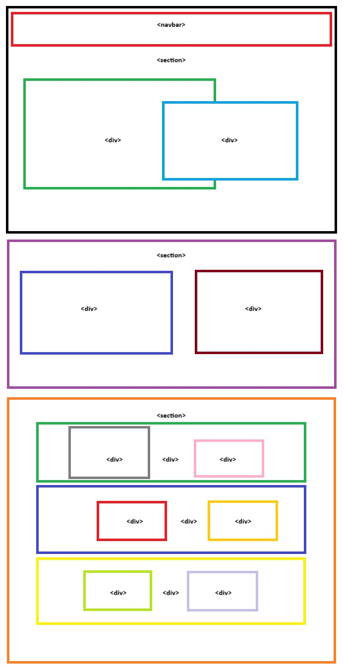

Figure 3.1 - Schematic diagram

* 1. **File Structure:**

The project is organized into several directories and files to maintain clarity and facilitate efficient development. The file structure includes the following main components:

countdown-timer/

│

├── css/

│ └── main.css # Cascading style sheets (CSS) files for styling the BMI calculator.

│

├── main.html # Main HTML file serving as the interface for the BMI calculator.

│

├── main.js # Main HTML file serving as the interface for the BMI calculator.

│

* 1. **Algorithms used:**

The BMI Calculator project primarily leverages front-end web development technologies such as HTML, JavaScript, and Bootstrap. While these technologies do not involve complex algorithms, certain algorithms may be employed for specific functionalities, such as:

BMI Calculation Algorithm: Utilizes JavaScript functions to calculate the Body Mass Index based on the user's input of height and weight measurements.

Form Validation Algorithm: Employs JavaScript validation functions to ensure that the user's input is within acceptable ranges and formats, enhancing the accuracy of BMI calculations. These algorithms play a crucial role in enhancing the functionality and accuracy of the BMI calculator, contributing to its effectiveness in providing users with valuable health information.

1. **Results:**
   1. **Screenshots:**

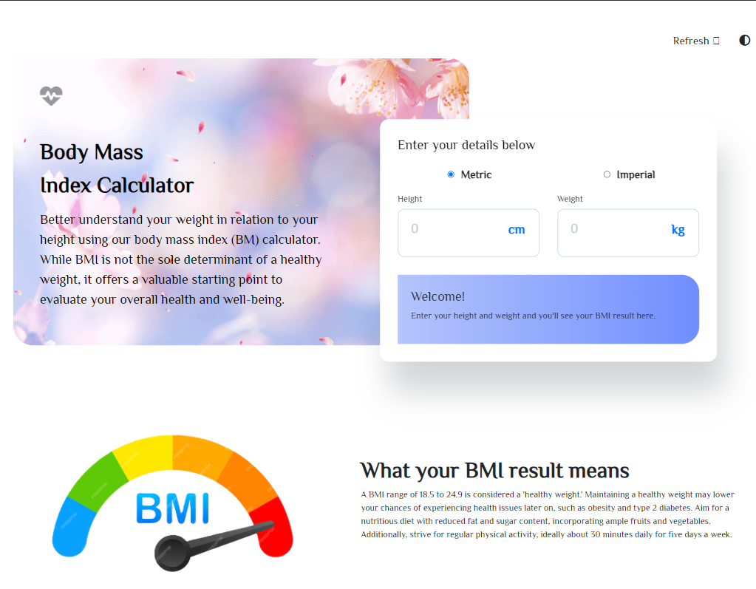

Figure 4.1 - Screenshot 1

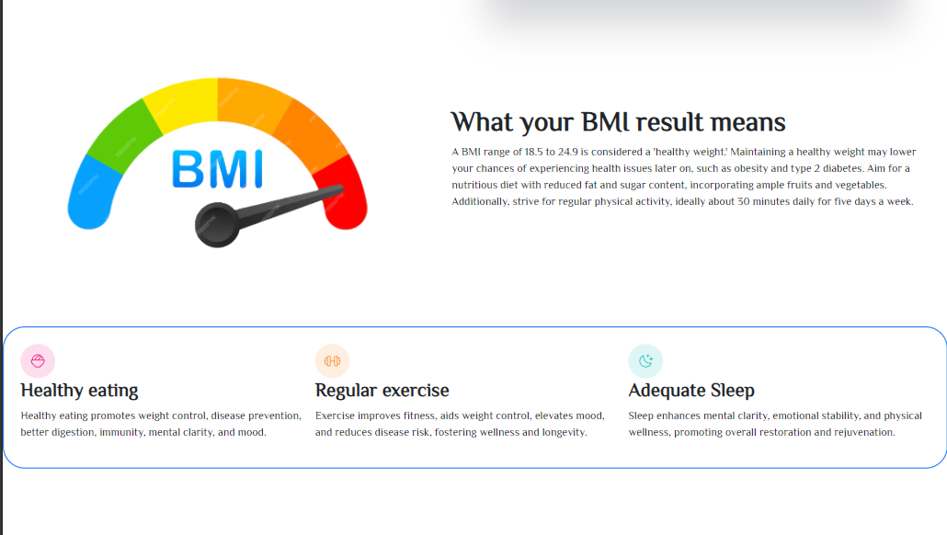

Figure 4.1 - Screenshot 2

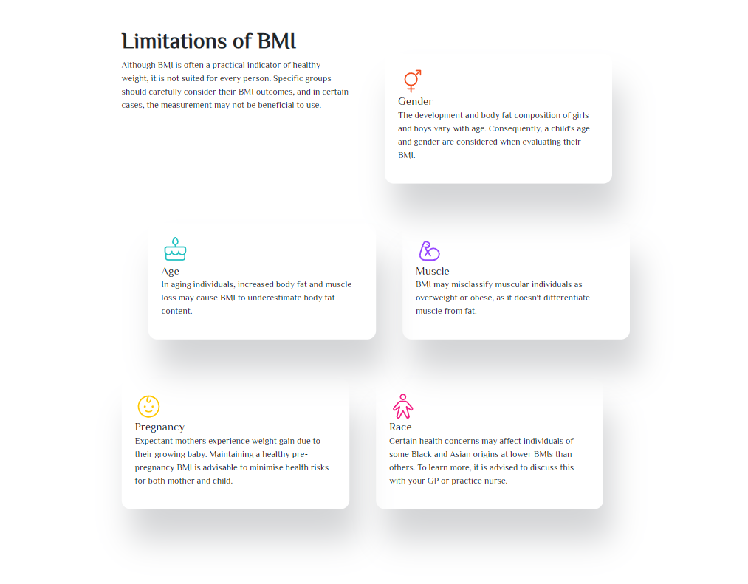

Figure 4.1 - Screenshot 3

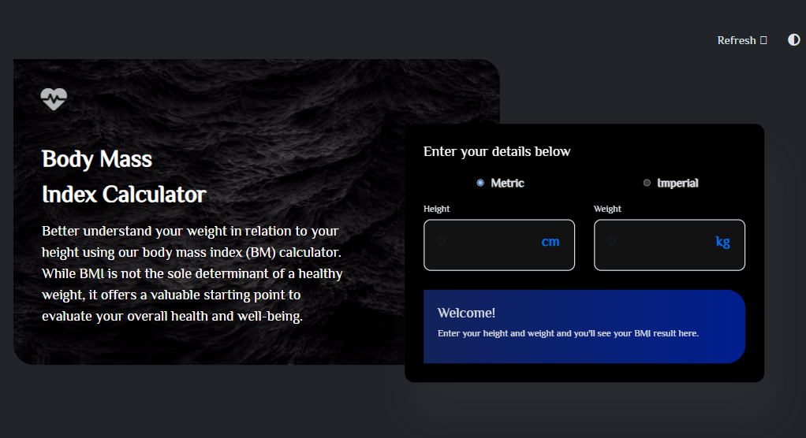

Figure 4.1 - Screenshot 4

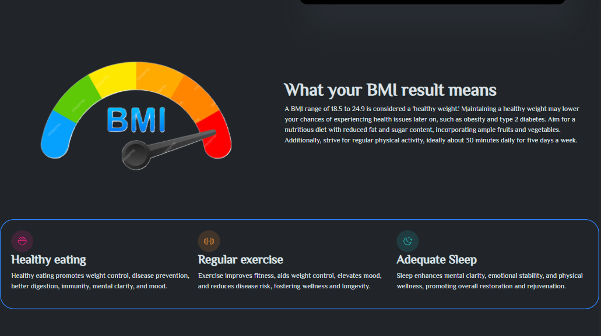

Figure 4.1 - Screenshot 5

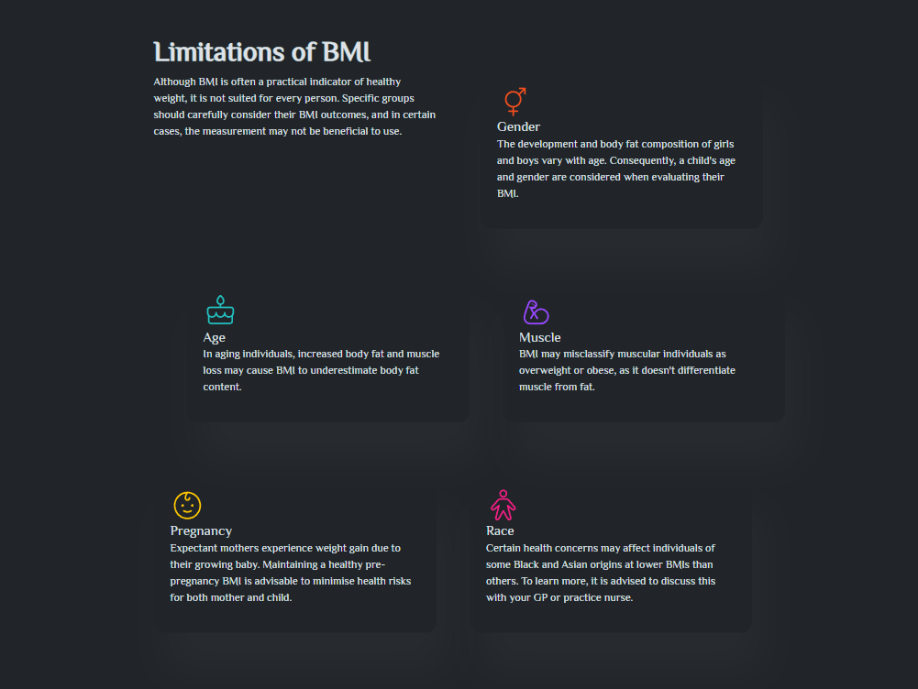

Figure 4.1 - Screenshot 6

* 1. **Metrics:**

In evaluating the performance and effectiveness of the BMI Calculator project, the following metrics were considered:

Page Load Time: The average time taken for the BMI calculator to load across different devices and internet connections.

Responsiveness: Evaluation of the BMI calculator's responsiveness across various screen sizes and resolutions, ensuring optimal user experience.

User Interaction: Metrics related to user engagement, such as the number of interactions with the BMI calculator, session duration, and frequency of use.

Accuracy: Analysis of the BMI calculator's accuracy in calculating Body Mass Index based on user input of height and weight measurements.

User Satisfaction: Feedback from users regarding the usability, clarity of results, and overall satisfaction with the BMI calculator. These metrics provide valuable insights into the performance, user experience, and effectiveness of the BMI Calculator project, enabling continuous improvement and optimization to better serve the needs of users seeking to monitor their physical well-being.

* 1. **HTML Code:**

<!DOCTYPE html>

<html lang="en">

<head>

  <meta charset="UTF-8">

  <meta name="viewport" content="width=device-width, initial-scale=1.0">

  <link rel="stylesheet" href="main.css">

  <link rel="stylesheet" href="https://cdnjs.cloudflare.com/ajax/libs/font-awesome/6.5.2/css/all.min.css">

  <link rel="stylesheet" href="https://fonts.googleapis.com/css?family=Headland One|Handlee|Philosopher|Roboto">

  <link href="https://cdn.jsdelivr.net/npm/bootstrap@5.3.1/dist/css/bootstrap.min.css" rel="stylesheet"

    integrity="sha384-4bw+/aepP/YC94hEpVNVgiZdgIC5+VKNBQNGCHeKRQN+PtmoHDEXuppvnDJzQIu9" crossorigin="anonymous">

  <link rel="icon" href="apple-touch-icon.png" type="image/x-icon">

  <title>BMI Calculator</title>

</head>

<body>

  <nav class="navbar navbar-expand-lg d-flex justify-content-end pt-5">

    <button type="button" value="Relod Page" onclick="window.location.href=window.location.href"

      class="btn btn-lg">Refresh

      <i class="fa-solid fa-arrows-rotate fa-spin"></i>

    </button>

    <button id="dark-mode-toggle" class="btn btn-lg">

      <i class="fa-solid fa-circle-half-stroke"></i>

    </button>

  </nav>

  <section class="sec1">

    <div class="side-container p-5" id="specified-div">

      <i class="fa-solid fa-heart-pulse fa-beat-fade logo fs-1"></i><br>

      <div class="side-elements-text d-flex flex-column pt-5" id="side-elements">

        <p class=" fs-1 fw-bolder">Body Mass <br>Index Calculator</p>

        <p class="fs-4">Better understand your weight in relation to your height using our

          body mass index (BM) calculator. While BMI is not the sole determinant

          of a healthy weight, it offers a valuable starting point to evaluate

          your overall health and well-being.</p>

      </div>

    </div>

    <div class="bmi-card" id="bcard">

      <h4 class="cardtext">Enter your details below</h4>

      <form class="radios d-flex justify-content-around align-items-center">

        <label class="radio-box d-flex justify-content-center align-items-center">

          <input type="radio" name="type" id="metric" class="radio" checked>

          <p class="heading-s pt-3 cardtext fs-5 fw-semibold">Metric</p>

        </label>

        <label class="radio-box d-flex justify-content-center align-items-center">

          <input type="radio" name="type" id="imperial">

          <p class="heading-s pt-3 cardtext fs-5 fw-semibold">Imperial</p>

        </label>

      </form>

      <form id="inputMetric">

        <div class="size-input d-flex flex-column">

          <label for="height" class="body-s cardtext">Height</label>

          <label data-domain="cm" class="attach position-relative d-block">

            <input type="number" class="input-field position-relative d-block" id="cm" placeholder="0">

          </label>

        </div>

        <div class="size-input d-flex flex-column">

          <label for="weight" class="body-s cardtext">Weight</label>

          <label data-domain="kg" class="attach position-relative d-block">

            <input type="number" class="input-field position-relative d-block" id="kg" placeholder="0">

          </label>

        </div>

      </form>

      <form class="imperial hide" id="inputImperial">

        <div class="size-input">

          <label for="height" class="body-s cardtext">Height</label>

          <div class="imperial-input">

            <label data-domain="ft" class="attach position-relative d-block">

              <input type="number" class="input-field position-relative d-block" placeholder="0" id="ft">

            </label>

            <label data-domain="in" class="attach position-relative d-block">

              <input type="number" class="input-field position-relative d-block" placeholder="0" id="in">

            </label>

          </div>

        </div>

        <div class="size-input">

          <label for="weight" class="body-s cardtext">Weight</label>

          <div class="imperial-input">

            <label data-domain="st" class="attach position-relative d-block">

              <input type="number" class="input-field position-relative d-block" placeholder="0" id="st">

            </label>

            <label data-domain="lbs" class="attach position-relative d-block">

              <input type="number" class="input-field position-relative d-block" placeholder="0" id="lbs">

            </label>

          </div>

        </div>

      </form>

      <div class="results p-4 rounded-end-5 show" id="welcome">

        <h5 class="heading-m fs-4">Welcome!</h5>

        <p class="body-s">Enter your height and weight and you'll see your BMI result here.</p>

      </div>

      <div class="calculated-answer hide" id="result">

        <div class="bmi d-flex flex-column">

          <p>Your BMI is...</p>

          <h1 id="bmi-score"></h1>

        </div>

        <p class="desc" id="bmi-desc">Your BMI suggests you’re <span id="healthy">a healthy weight</span>. Your ideal

          weight is between <span class="fw-70" id="range"></span></p>

      </div>

    </div>

  </section>

  <div id="space" class=""></div>

  <br>

  <br>

  <br>

  <br>

  <br>

  <br>

  <section class="bmi-meaning-container d-flex justify-content-around">

    <img src="BMI.png" width="40%" height="30%" alt="">

    <div class="bmi-meaning-text d-flex flex-column">

      <h3 class="fs-1 fw-bold">What your BMI result means</h3>

      <p class="body-m"> A BMI range of 18.5 to 24.9 is considered a 'healthy weight.' Maintaining a

        healthy weight may lower your chances of experiencing health issues later on,

        such as obesity and type 2 diabetes. Aim for a nutritious diet with reduced

        fat and sugar content, incorporating ample fruits and vegetables. Additionally,

        strive for regular physical activity, ideally about 30 minutes daily for

        five days a week.</p>

    </div>

  </section>

  <br>

  <br>

  <br>

  <br>

  <section class="steps d-flex justify-content-around rounded-5 p-3">

    <div class="feature d-flex flex-column p-2">

      <img src="icon-eating.svg" alt="" width="50px" height="50px">

      <h3 class="fw-bold">Healthy eating</h3>

      <p class=""> Healthy eating promotes weight control, disease prevention, better digestion,

        immunity, mental clarity, and mood.</p>

    </div>

    <div class="feature d-flex flex-column p-2">

      <img src="icon-exercise.svg" alt="" width="50px" height="50px">

      <h3 class="fw-bold">Regular exercise</h3>

      <p class="">Exercise improves fitness, aids weight control, elevates mood, and reduces disease risk, fostering

        wellness and longevity.</p>

    </div>

    <div class="feature d-flex flex-column p-2">

      <img src="icon-sleep.svg" alt="" width="50px" height="50px">

      <h3 class="fw-bold">Adequate Sleep</h3>

      <p class="">Sleep enhances mental clarity, emotional stability, and physical wellness, promoting

        overall restoration and rejuvenation.</p>

    </div>

  </section>

  <br>

  <br>

  <br>

  <br>

  <br>

  <br>

  <section class="limitations d-flex flex-column justify-content-around">

    <div class="limitrow d-flex align-items-top justify-content-center">

      <div class="limitations-text d-flex flex-column mx-3">

        <h3 class="fs-1 fw-bold">Limitations of BMI</h3>

        <p class="body-m">Although BMI is often a practical indicator of healthy weight, it is not suited for

          every person. Specific groups should carefully consider their BMI outcomes, and in

          certain cases, the measurement may not be beneficial to use.</p>

      </div>

      <div class="limitations-card d-flex flex-column p-4 mt-5 mx-5">

        <img src="icon-gender.svg" alt="" width="50px" height="50px">

        <h5 class="card-title heading-s">Gender</h5>

        <p class="body-m">The development and body fat composition of girls and boys vary with age. Consequently,

          a child's age and gender are considered when evaluating their BMI.</p>

      </div>

    </div>

    <br>

    <br>

    <br>

    <div class="limitrow d-flex justify-content-center align-items-center">

      <div class="limitations-card d-flex flex-column p-4 mx-5">

        <img src="icon-age.svg" alt="" width="50px" height="50px">

        <h5 class="card-title heading-s">Age</h5>

        <p class="body-m">In aging individuals, increased body fat and muscle loss may cause BMI to underestimate body

          fat content.</p>

      </div>

      <div class="limitations-card d-flex flex-column p-4">

        <img src="icon-muscle.svg" alt="" width="50px" height="50px">

        <h5 class="card-title heading-s">Muscle</h5>

        <p class="body-m">BMI may misclassify muscular individuals as overweight or obese, as it doesn't

          differentiate muscle from fat.</p>

      </div>

    </div>

    <br>

    <br>

    <br>

    <div class="limitrow d-flex justify-content-center align-items-center">

      <div class="limitations-card d-flex flex-column p-4">

        <img src="icon-pregnancy.svg" alt="" width="50px" height="50px">

        <h5 class="card-title heading-s">Pregnancy</h5>

        <p class="body-m">Expectant mothers experience weight gain due to their growing baby. Maintaining a

          healthy pre-pregnancy BMI is advisable to minimise health risks for both mother

          and child.</p>

      </div>

      <div class="limitations-card d-flex flex-column p-4 mx-5">

        <img src="icon-race.svg" alt="" width="50px" height="50px">

        <h5 class="card-title heading-s">Race</h5>

        <p class="body-m">Certain health concerns may affect individuals of some Black and Asian origins at

          lower BMIs than others. To learn more, it is advised to discuss this with your

          GP or practice nurse.</p>

      </div>

    </div>

  </section>

  <br>

  <br>

  <br>

  <br>

  <br>

  <br>

  <script type="module" src="main.js"></script>

</body>

</html>

* 1. **CSS Code:**

*{

  margin: 0;

  padding: 0;

  box-sizing: border-box;

  font-family: Philosopher;

}

:root{

  --overlay-opacity: linear-gradient(315deg, rgba(214, 230, 254, 0.25) 40%, rgba(214, 252, 254, 0.25) 100%);

  --borders: #ff6060;

  --white: #ffffff;

  --shad:16px 56px 56px 0px rgba(63, 68, 73, 0.226);

}

.sec1{

}

.side-container{

  width: 60%;

  background-position: center;

  background-repeat: no-repeat;

  background-size: cover;

  margin-left: 1.5rem;

  border-radius: 0rem 2.186rem 0rem 2.186rem;

}

.logo{

}

.side-elements-text {

}

.side-elements-text h1{

}

.side-elements-text p{

  width: 33rem;

}

.bmi-card{

  top: 20%;

  left: 50%;

  position:absolute;

  background-color: white;

  box-shadow: var(--shad);

  border-radius: 1rem;

  padding:2rem;

}

.heading-m{

}

.heading-s{

}

form{

  display: flex;

  gap: 2rem;

}

.radios{

}

.radio-box p{

}

.radio-box{

  cursor: pointer;

}

.size-input{

}

.input-field{

  margin-top: 0.4rem;

  padding: 1rem 1.4rem;

  width: 16rem;

  border-radius: 0.75rem;

  border: 2px solid #D8E2E7;

  font-weight: bold;

  font-size: 24px;

}

.attach, .input-field{

  padding-bottom: 2rem;

  box-sizing: border-box;

}

.imperial{

  display: flex;

  flex-direction: column;

}

.hide{

  display: none !important;

}

.show{

  display: block;

}

input[type="radio"]{

  width: 2.2rem;

  background-color: green;

  border: 1px solid black;

}

input[type="radio"]:checked{

  background-color: gray;

}

input[type="radio"]:hover{

  cursor: pointer;

  border-color: red;

}

input[type="radio"]::before{

  content: "";

  width: 15px;

  transform: scale(0);

  transition: 120ms transform ease-in-out;

  box-shadow: inset 1em 1em red;

}

input[type="radio"]:checked::before{

  transform: scale(1);

}

.imperial-input{

  display: flex;

  gap: 2rem;

}

input[type=number]::-webkit-inner-spin-button,

input[type=number]::-webkit-outer-spin-button{

  -webkit-appearance: none;

  margin: 0;

}

.attach::after{

  content: attr(data-domain);

  position: absolute;

  top: 21%;

  right: 10%;

  font-size: 24px;

  font-weight: bold;

  color: var(--blue);

}

.input-field::placeholder{

  color: var(--gunmetal);

  opacity: 0.25;

}

.input-field:focus{

  outline: none;

  border: 2px solid var(--blue) !important;

}

.results{

  background: linear-gradient(90deg, #345ef65d 0%, #0037ff90 100%);

}

.results h5{

}

.calculated-answer{

  background: linear-gradient(90deg, #345ef65d 0%, #0037ff90 100%);

  border-radius: 0 52rem 52rem 0;

  display: flex;

  padding: 1rem;

  justify-content: space-around;

  align-items: center;

}

.bmi{

}

.bmi h1{

}

.bmi p{

}

.desc{

  width: 14rem;

}

.body-m{

}

.body-s{

}

.heading-l{

}

.curve-left{

}

.curve-left img{

}

.bmi-meaning-container{

}

.bmi-meaning-container img{

}

.bmi-meaning-text{

  justify-content: center;

  width:50%;

}

.bmi-meaning-text h3{

}

.bmi-meaning-text p{

}

.inter-bold{

  font-size: 16px;

  line-height: 150%;

  font-weight: bold;

}

.space-imp-wel{

  margin-top: 8%;

  margin-bottom: 0%;

}

.space-imp-sp{

  margin-top: 14%;

}

.steps{

  border:2px solid rgb(45, 132, 255);

}

.steps img{

}

.steps h3{

}

.steps-container{

}

.steps-p{

}

.steps-p1{

}

.limitations{

}

.limitations-text{

  width:30%;

}

.limitations-text p{

}

.limitations-card{

  width:30%;

  box-shadow: var(--shad);

  border-radius: 1rem;

  height:fit-content;

}

.cards{

}

* 1. **Java Script code:**

(() => {

    'use strict';

    const getStoredTheme = () => localStorage.getItem('theme');

    const setStoredTheme = theme => localStorage.setItem('theme', theme);

    const getPreferredTheme = () => {

        const storedTheme = getStoredTheme();

        if (storedTheme) {

            return storedTheme;

        }

        return window.matchMedia('(prefers-color-scheme: dark)').matches ? 'dark' : 'light';

    };

    const setTheme = theme => {

        if (theme === 'auto') {

            document.documentElement.setAttribute('data-bs-theme', (window.matchMedia('(prefers-color-scheme: dark)').matches ? 'dark' : 'light'));

        } else {

            document.documentElement.setAttribute('data-bs-theme', theme);

        }

        // Change wallpaper of specified div based on theme

        const specifiedDiv = document.getElementById('specified-div');

        if (specifiedDiv) {

            if (theme === 'dark') {

                specifiedDiv.style.backgroundImage = `url('darkmode.gif')`;

                specifiedDiv.querySelector('.side-elements-text').style.color = 'white';

            } else {

                specifiedDiv.style.backgroundImage = `url('lightmode.gif')`;

                specifiedDiv.querySelector('.side-elements-text').style.color = 'black';

            }

        }

        const bmiCard = document.getElementById('bcard');

        if (bmiCard) {

            if (theme === 'dark') {

                bmiCard.style.backgroundColor = 'black';

                bmiCard.querySelector('.cardtext').style.color = 'white';

            } else {

                bmiCard.style.backgroundColor = 'white';

                bmiCard.querySelector('.cardtext').style.color = 'black';

            }

        }

    };

    setTheme(getPreferredTheme());

    const showActiveTheme = (theme, focus = false) => {

        const themeSwitcher = document.querySelector('#bd-theme');

        if (!themeSwitcher) {

            return;

        }

        const themeSwitcherText = document.querySelector('#bd-theme-text');

        const activeThemeIcon = document.querySelector('.theme-icon-active use');

        const btnToActive = document.querySelector(`[data-bs-theme-value="${theme}"]`);

        const svgOfActiveBtn = btnToActive.querySelector('svg use').getAttribute('href');

        document.querySelectorAll('[data-bs-theme-value]').forEach(element => {

            element.classList.remove('active');

            element.setAttribute('aria-pressed', 'false');

        });

        btnToActive.classList.add('active');

        btnToActive.setAttribute('aria-pressed', 'true');

        activeThemeIcon.setAttribute('href', svgOfActiveBtn);

        const themeSwitcherLabel = `${themeSwitcherText.textContent} (${btnToActive.dataset.bsThemeValue})`;

        themeSwitcher.setAttribute('aria-label', themeSwitcherLabel);

        if (focus) {

            themeSwitcher.focus();

        }

    };

    window.matchMedia('(prefers-color-scheme: dark)').addEventListener('change', () => {

        const storedTheme = getStoredTheme();

        if (storedTheme !== 'light' && storedTheme !== 'dark') {

            setTheme(getPreferredTheme());

        }

    });

    window.addEventListener('DOMContentLoaded', () => {

        showActiveTheme(getPreferredTheme());

        document.querySelectorAll('[data-bs-theme-value]')

            .forEach(toggle => {

                toggle.addEventListener('click', () => {

                    const theme = toggle.getAttribute('data-bs-theme-value');

                    setStoredTheme(theme);

                    setTheme(theme);

                    showActiveTheme(theme, true);

                });

            });

        // Add event listener to Dark Mode button

        const darkModeToggle = document.getElementById('dark-mode-toggle');

        darkModeToggle.addEventListener('click', () => {

            const currentTheme = getStoredTheme();

            const newTheme = currentTheme === 'dark' ? 'light' : 'dark';

            setStoredTheme(newTheme);

            setTheme(newTheme);

            showActiveTheme(newTheme, true);

        });

    });

  })();

  let radioMetric = document.getElementById("metric")

  let radioImperial = document.getElementById("imperial")

  let inputImperial = document.getElementById("inputImperial")

  let inputMetric = document.getElementById("inputMetric")

  let space = document.getElementById("space")

  //metric values

  let cm = document.getElementById("cm")

  let kg = document.getElementById("kg")

  //imperial values

  let ft = document.getElementById("ft")

  let inch = document.getElementById("in")

  let st = document.getElementById("st")

  let lbs = document.getElementById("lbs")

  //results

  let welcome = document.getElementById("welcome")

  let calculatedAnswer = document.getElementById("result")

  let bmiScore = document.getElementById("bmi-score")

  let description = document.getElementById("bmi-desc")

  let healthy = document.getElementById("healthy")

  let range = document.getElementById("range")

  radioImperial.addEventListener("change", () => {

      if (radioImperial.checked) {

          inputImperial.classList.remove("hide")

          inputMetric.classList.add("hide")

          space.classList.add("space-imp-wel")

      }

      if (welcome.classList.contains("hide")){

          welcome.classList.remove("hide")

          calculatedAnswer.classList.add("hide")

      }

  })

  radioMetric.addEventListener("change", () => {

      if (radioMetric.checked){

          inputImperial.classList.add("hide")

          inputMetric.classList.remove("hide")

          space.classList.remove("space-imp-wel")

      }

      if (welcome.classList.contains("hide")){

          welcome.classList.remove("hide")

          calculatedAnswer.classList.add("hide")

      }

  })

  //Calculate metric BMI and indicate weight class

  function calculateMetricBMI (heightMeters, weightKg) {

      if(isNaN(weightKg) || isNaN (heightMeters)){

          bmiScore.innerHTML = "NaN"

          description.innerHTML = "Please provide numerical values"

      }

      heightMeters = cm.value/100

      let bmi = weightKg / (heightMeters * heightMeters)

      //weight class

      if (bmi > 24.9) {

          healthy.innerHTML = "overweight"

      }else if (bmi < 18.5){

          healthy.innerHTML = "underweight"

      }else{

          healthy.innerHTML = "at a healthy weight"

      }

      //weight range

      let weightLower = (18.5 * (heightMeters * heightMeters)).toFixed(1) + "kg"

      let weightHigher = (24.9 * (heightMeters * heightMeters)).toFixed(1) + "kg."

      range.innerHTML = weightLower + " - " + weightHigher

      return bmi

  }

  //calculate imperial BMI and indicate weight class

  function calculateHeightConversion(heightFeet, heightInch) {

      let heightConvert = ((heightFeet * 30.48 + heightInch * 2.54)/100)

      heightConvert = (heightConvert * heightConvert)

      return heightConvert

  }

  function calculateWeightConversion(weightStone, weightPound) {

      let weightConvert = (weightStone * 6.35029 + weightPound * 0.45359237)

      return weightConvert

  }

  function weightClassRange() {

      let bmi2 = (calculateWeightConversion(st.value, lbs.value) / calculateHeightConversion(ft.value, inch.value)).toFixed(1)

      if (bmi2 > 24.9) {

          healthy.innerHTML = "overweight"

      }else if (bmi2 < 18.5){

          healthy.innerHTML = "underweight"

      }else{

          healthy.innerHTML = "at a healthy weight"

      }

      let lowerWeight = (18.5 * calculateHeightConversion(ft.value, inch.value)) * 2.205

      let lowerWeightSt= Math.floor(lowerWeight * 0.0714) + "st"

      let lowerWeightPound = Math.floor(lowerWeight % 14) + "lbs"

      let upperWeight = (24.9 * calculateHeightConversion(ft.value, inch.value)) * 2.205

      let UpperWeightSt= Math.floor(upperWeight * 0.0714) + "st"

      let upperWeightPound = Math.floor(upperWeight % 14) + "lbs"

      range.innerHTML = lowerWeightSt + " " + lowerWeightPound  + " - " + UpperWeightSt + " " + upperWeightPound

      return bmi2

  }

  //Display results

  function displayMetricResults() {

      if(cm.value !== "" || kg.value !== ""){

          welcome.classList.add("hide")

          calculatedAnswer.classList.remove("hide")

          bmiScore.innerHTML = (calculateMetricBMI(cm.value, kg.value)).toFixed(1)

      }else if(cm.value === "" && kg.value === "") {

          bmiScore.innerHTML = 0

      }

  }

  function displayImperialResults() {

          welcome.classList.add("hide")

          calculatedAnswer.classList.remove("hide")

          space.classList.add("space-imp-sp")

          bmiScore.innerHTML = weightClassRange()

  }

  cm.addEventListener("input", displayMetricResults)

  kg.addEventListener("input", displayMetricResults)

  ft.addEventListener("input", displayImperialResults)

  inch.addEventListener("input", displayImperialResults)

  st.addEventListener("input", displayImperialResults)

  lbs.addEventListener("input", displayImperialResults)

1. **References:**

Font Awesome Icons: Employed for adding scalable vector icons to the user interface. Citation: Font Awesome. (n.d.). Retrieved from <https://fontawesome.com/>

Google Fonts: Utilized for incorporating custom fonts into the design. Citation: Google Fonts. (n.d.). Retrieved from <https://fonts.google.com/>

Unsplash: Source of high-quality, royalty-free images used in the project. Citation: Unsplash. (n.d.). Retrieved from <https://unsplash.com/>

Bootstrap: Bootstrap is used in this project for styling. Retrieved from <https://getbootstrap.com/>

These references provide valuable resources and tools that were utilized in the development of the BMI Calculator project. Proper citation ensures acknowledgment of the contributions and adherence to best practices in web development.